Exploring connections to nature and sustainability through a process of experiential arts based inquiry.

Erica Gurner;
HumaNature Connect

Natalya Garden-Thompson
Masters candidate Experiential and Creative Arts Practice, MIECAT.

Maureen Carey
Out Doors Inc. Fitzroy, VIC

Introduction

For human beings “….the natural world is alive with stories. Places, plants, animals and people are woven together in a vibrant tapestry of history, legend and beliefs…” (The Nature Conservancy).
These words describe a relationship with nature and culture that is usually associated with Aboriginal societies. It is well recognised that these people have lived for millions of years, sustaining an ecological understanding of themselves and their place amongst the animate and inanimate natural world. However, what may be a less considered view point is the one presented here, informed by the field of Ecopsychology i.e. that all human beings are part of the natural world; one interdependent ecological system – Gaia; one soul - Anima Mundi (Roszak 1995). Through a subjective lens, the weaving of individual experience and culture may stir in a person an inherent sense of connection and ‘knowing’ i.e. a kinship, an understanding of cause and effect, that is essential to wellbeing for all human beings not just those of indigenous heritage (Hillman 1995; Mack 1995). From this perspective there is also a direct relationship between sense of connection to the natural world and the way people treat it (Kollman &Ageyman 2002).
In our technological and economically focused society, one that values objective solutions and explanations, a phenomenological perspective such as this presents a challenge to mainstream thought. Colin Mortlock puts it simply: “The underlying problem of the man-made world is that it is built on human separateness”. Long gone is the holistic thinking of the majority of early western scientists and healers whose works was informed by a mix of philosophy, spirtuality, intuition, logic and the arts; these approaches are now considered ‘alternative’. All these factors together have resulted in fewer opportunities for people to experience and ‘know’ the natural world and to build meaningful relationship and connections with it. This is proving to be folly as it is now broadly recognised that there is a major cost to human wellbeing and development in both adults (Townsend and Ebden 2006) and children (Louv 2008). The cost to the environment is dire!

Context
In considering the theme of the conference: ‘Courageous Next Steps’ relating to environmental education and sustainability, we believe that as professionals and as concerned citizens, we can facilitate, develop and maintain understanding of human relationships and connections to nature. This knowledge can then serve as a building block to holistic, innovative and meaningful solutions to the ecological challenges that we face. Achieving sustainability is more likely if we seek to ‘know’ the very thing we are trying to sustain and keep that close as we dialogue with others. Like the Scientists of old and indigenous cultures have shown us, understanding is best served through a mix of experience, logic, intuition, spirituality and arts.
Experiential - Arts Based Form of Inquiry
To ‘know’ is to have found meaning, to find meaning is a lifelong personal journey and experiential and arts based forms of inquiry are useful tools for this meaning making.
“There is a language older by far and deeper than words. It is the language of bodies, of body on body, wind and snow, rain on trees, wave on stone. It is the language of dream, gesture, symbol, memory” (Jensen, 2000).
Arts based inquiry encourages us to explore and make sense of our lived experiences. It has the ability to unlock feelings serving as a language that can transcend words. This form of inquiry has been strongly influenced by experiential learning and theory and phenomenology. Briefly, experiential learning theory was popularised by David Kolb in the 1970’s and 80’s (Smith 2001) and put simply describes a process by which individuals create meaning through cycles of concrete experience, reflection, testing and application. It can be a way of uniting, experience, intuition, observation and knowledge. Phenomenology is concerned with the “study of structures of experience, or consciousness” and addresses “the meaning things have in our experience, notably, the significance of objects, events, tools, the flow of time, the self, and others ...” (Woodroofe 2008)
In arts based inquiry, creative explorations become access points into a process of understanding experience in the context of the present moment. “They source the multitude of visual images connected to feeling, emotions, and ideas that are held within. When we indwell or stay reflectively in such processes, during and after their forming, this access allows the movement into sense-making in conscious awareness and then to further knowing” (Lett, 2011. p. 13).
Creative expression (in its many forms) can therefore be a powerful medium for uncovering what is known, how it is known and what will be done with this new knowing. Heron and Reason (2006) say “…our knowing is grounded in our experience, expressed through our stories and images, understood through theories which make sense to us and expressed in worthwhile action in our lives” (p. 14).
Model of the Experiential & Arts based Inquiry Process
The model depicted in Figure 1 informs the activities of an experiential arts based form of inquiry. It is not necessarily followed around sequentially but rather may cycle between ‘steps’ as the inquiry unfolds.

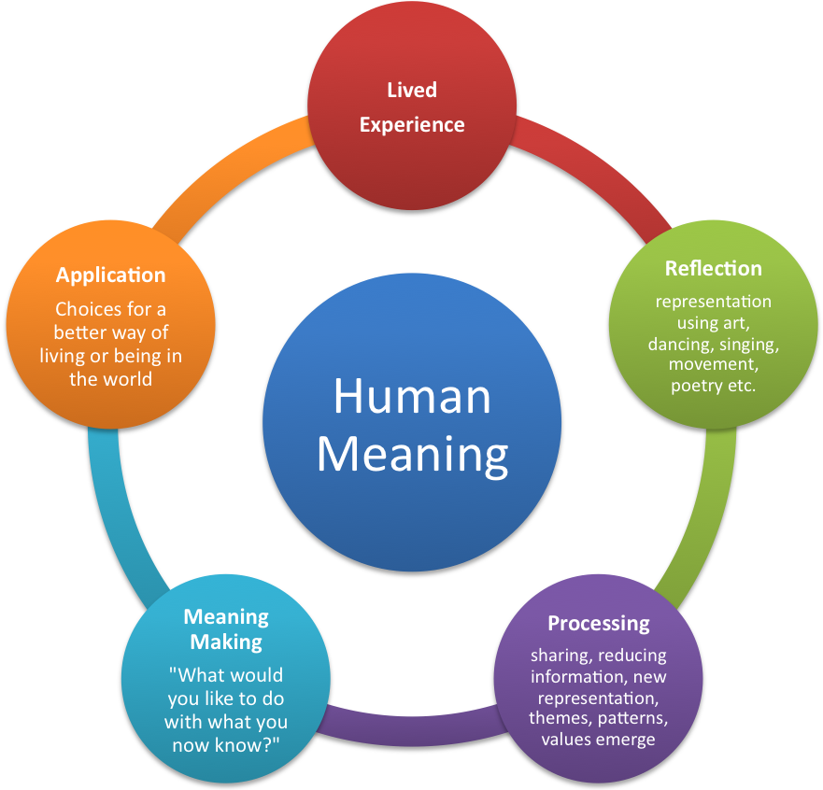

Figure 1. Model of the experiential & arts based inquiry process
Workshop Activity (as presented at AAEE conference 2012)
This workshop was delivered at the Australian Association of Environmental Educators (AAEE) Conference, October 2012. In this workshop we invited participants to join in the following inquiry. Each dot point describes a task that represents a step in the model represented in Figure 1. This step is indicated in brackets on the right and highlights the way in which multiple steps may be repeated during the inquiry.
- Reflecting on a special place or experience in your life (Lived experience)
- Selecting an image/object to represent your place or experience (Reflection)
- Reflecting on what sustainability means to you (Lived experience)
- Selecting a word relating to sustainability or writing own (Reflection)
- Selecting a material, then physically binding the two together (Reflection)
- Sharing emerging meaning and insights with a partner (Processing)
- Take home question … (Meaning Making)
- “In considering our courageous next steps, what message does this object have for you?”
- How you chose to live out your Next Courageous Steps based on what you have come to know about sustainability and connections with nature ? (Application)

Conclusion &Summary
The positive health of the entire natural world, including human beings is dependent upon developing holistic solutions to the challenges of environmental sustainability. These solutions must give consideration to the strong influence that positive human-nature relationships and connections have on wellbeing and actions. This relationship was explored in a workshop presented at the AAEE conference 2012; Participants were taken through an experiential arts based process where they were invited to reflect upon places or experiences in nature that are important or special to them and select an image or object that reflected that experience. We then reframed this experience into a context of environmental sustainability through offering words and concepts selected from the conference proceedings that may have reflected their values in relation to sustainability. By then binding the two together with a meaningful material, we symbolised their relationship in this moment; one informing the other and assisting the creator in discovering their own meaning. How this meaning is taken into further actions is up to the creator.

References
Heron, J. & Reason, P. (2006) The Practice of Co-operative Inquiry: Research with rather than on people. Reason & H. Bradbury (Eds.) Handbook of Action Research, pp. 179-188. Thousand Oaks, CA: Sage.
Hillman, J. (2005). A psyche the size of the earth. In Roszak, T, Gome, E. Kanner, A. (Eds.), Ecopsychology. Restoring the Earth Healing the Mind. (pp. 1-17). San Francisco: Sierra Club Books.
Jensen, D. (2000). A Language Older than Words, New York: Context Books
Kollmuss, A. & Agyeman, J. (2002). Mind the Gap: why do people act environmentally and what are the barriers to pro-environmental behavior. Environmental Education Research, 8(3) pp. 239 -260.
DOI: 10.1080/1350462022014540 1.
Lett, W. (2011) Making Sense of our Lives, Eltham: Rebus Press.
Lipsett, L. (2011). Creative Nature Connection: A Nature-based Art Practice for Schools. Retrieved [11/09/2012] from http://www.naturearteducation.org/Articles/LipsettCNCelementary.pdf
Louv, R. (2008). Last Child in the Woods. Saving our children from nature –deficit disorder. New York: Workman Publishing Company, Inc.
Mack, J. (2005). The Policies of Species Arrogance. In Roszak, T, Gome, E. Kanner, A. (Eds.), Ecopsychology. Restoring the Earth Healing the Mind. (pp. 1-17). San Francisco: Sierra Club Books.
Mortlock, C. (date unknown). Spirit of Adventure Foundation. Retrieved [12/09/2012] from http://www.soadventure.org/ .
Roszak, T. (2005). Where Psyche Meets Gaia. In Roszak, T, Gome, E. Kanner, A. (Eds.), Ecopsychology. Restoring the Earth Healing the Mind. (pp. 1-17). San Francisco: Sierra Club Books.
Smith, M. K. (2001). 'David A. Kolb on experiential learning', the encyclopedia of informal education. Retrieved [12/09/2012] from http://www.infed.org/b-explrn.htm
Woodruff, D. (2008). Stanford Encyclopedia of Philosophy. Phenomonology. Retrieved [21/11/2012] from http://plato.stanford.edu/entries/phenomenology/
Townsend, M. &Ebden, M. (2006). Feel Blue, Touch Green. Final report of a project undertaken by Deakin University, Barwon Health, Parks Victoria, Alcoa Anglesea, ANGAIR and Surf Coast Shire. Retrieved [12/09/2012] from http://www.interenvironment.org/cipa/Feel%20Blue,%20Touch%20Green.pdf
The Nature Conservancy (2011). Australia. Restoring Lost Connections. Retrieved [12/09/2012] from
http://www.nature.org/ourinitiatives/regions/australia/explore/restoring-lost-connections.xml.

